8.25: so

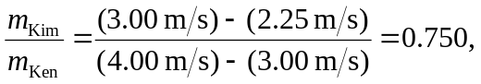

and Kim weighs 